# MAC Frame

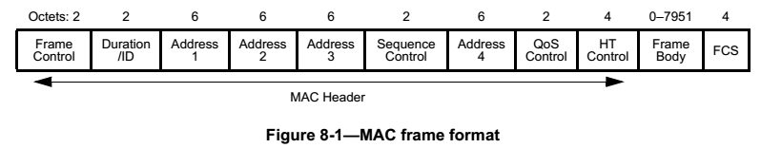

## Frame Control

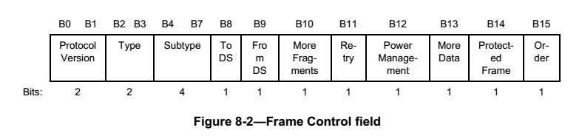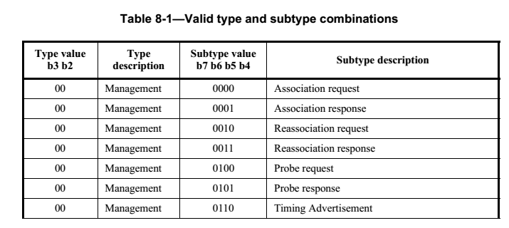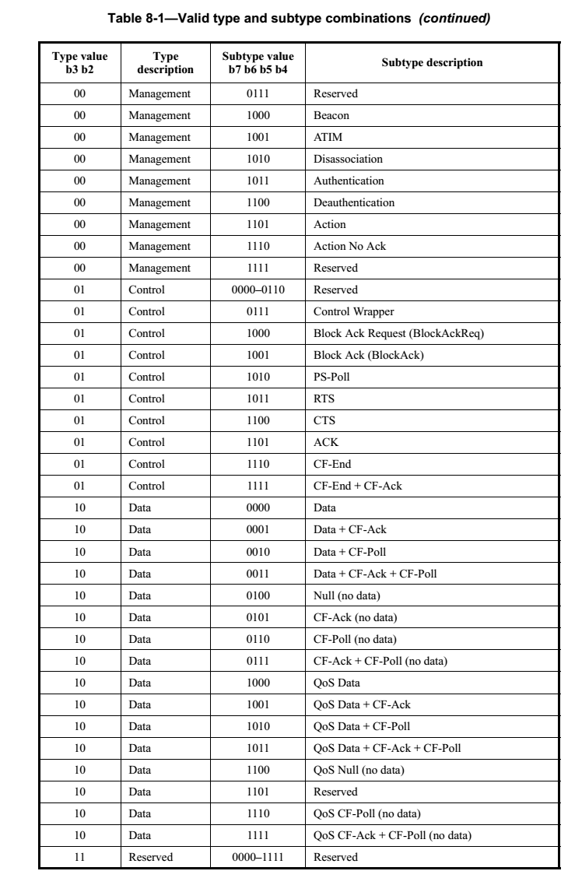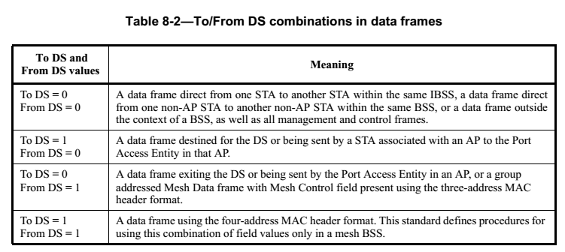

## Duration/ID

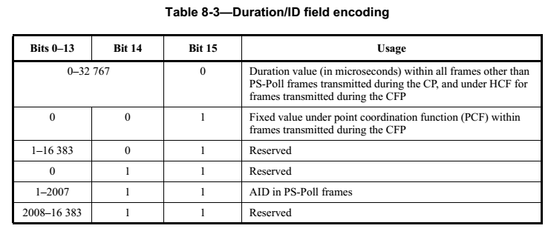

## Sequence Control

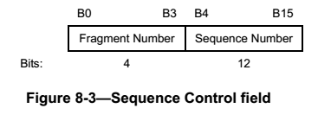

## Qos Control

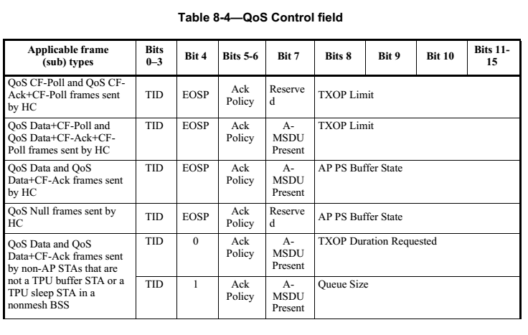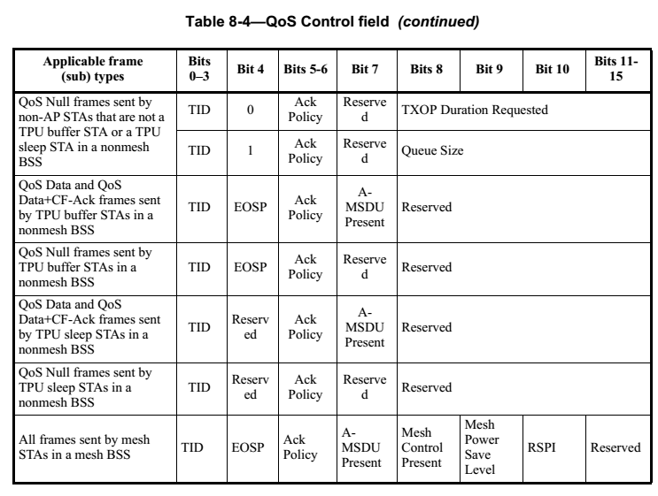

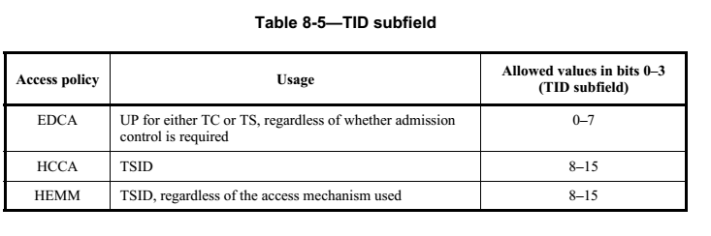

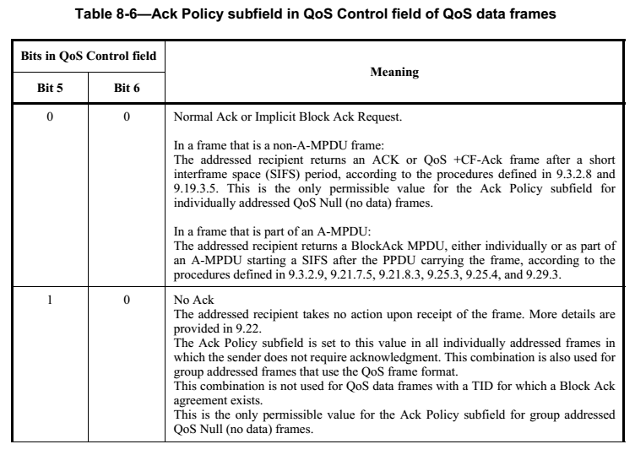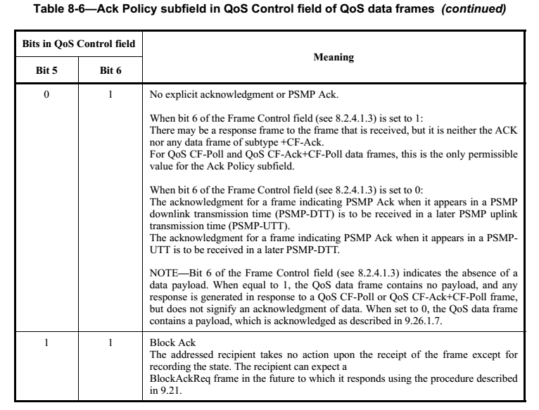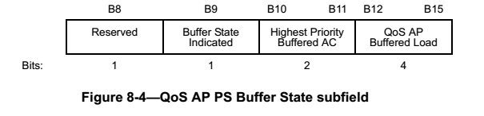

## HT Control

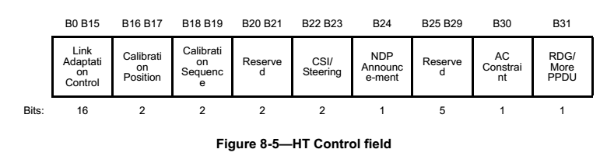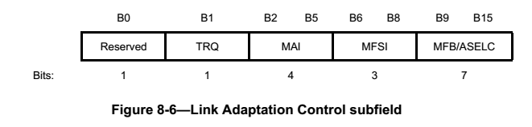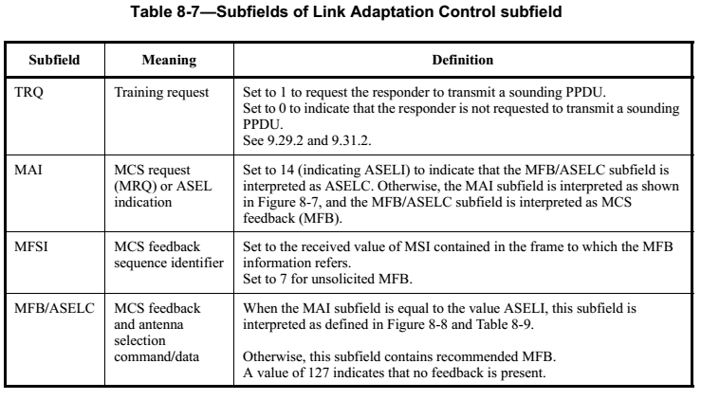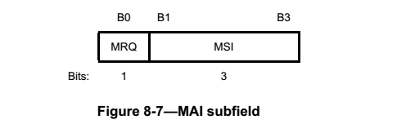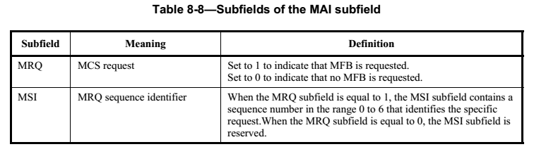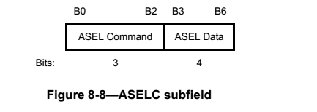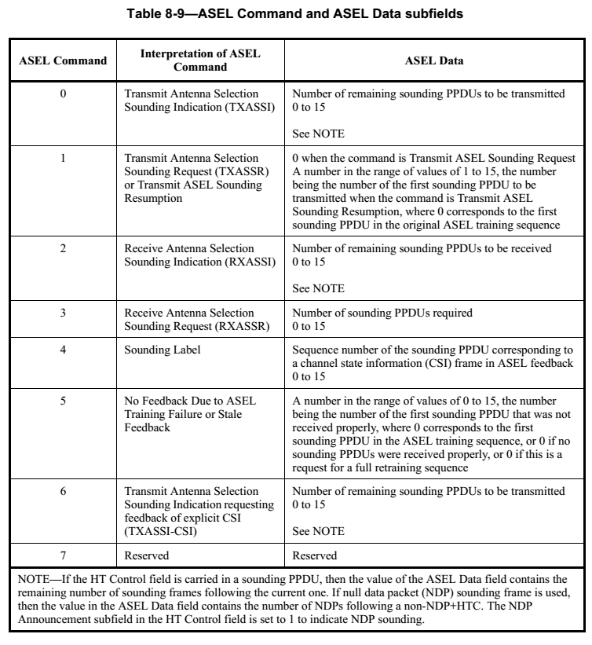

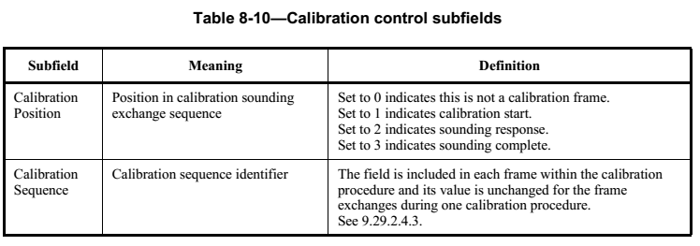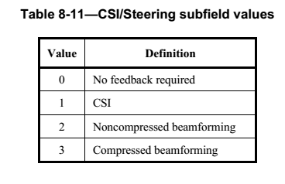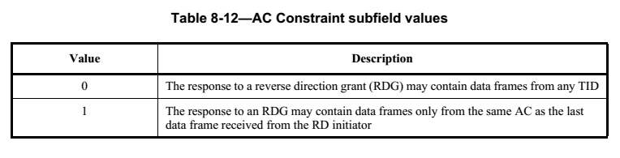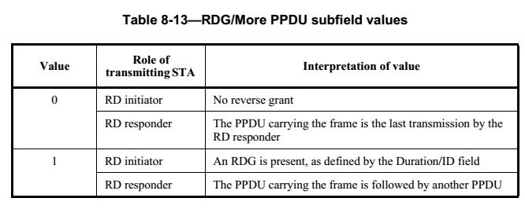

## Frame Body

**Mesh Control Field**

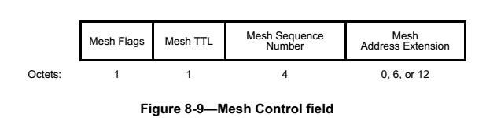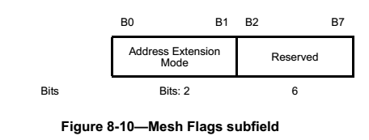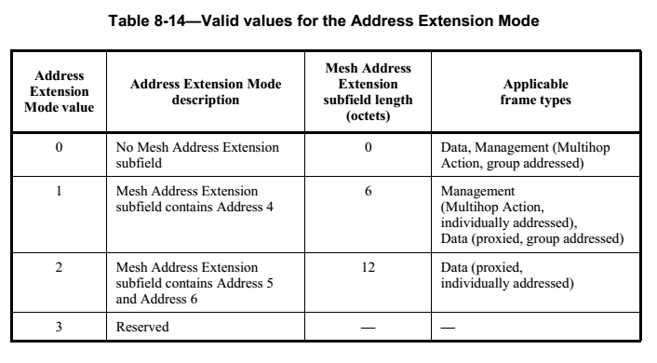

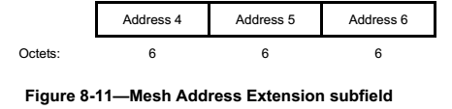

## FCS Field

The FCS field is a 32-bit field containing a 32-bit CRC. The FCS is calculated over all the fields of the MAC header and the Frame Body field.

# Control Frames

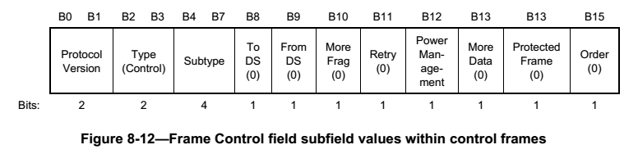

## RTS Frame

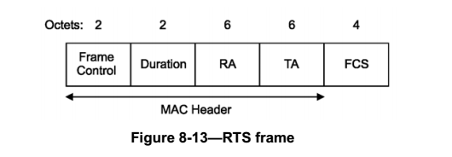

## CTS Frame

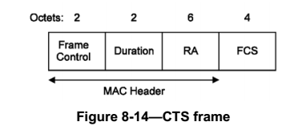

## ACK Frame

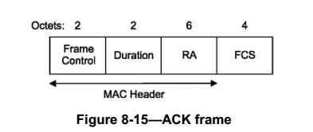

## PS-Poll Frame

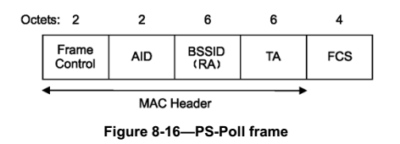

## CF-End Frame

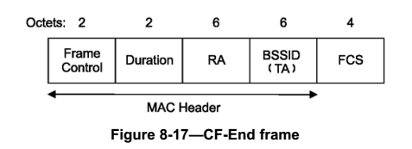

## CF-END+CF-Ack Frame

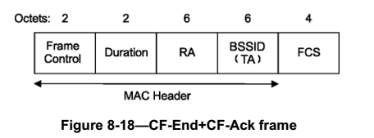

## BlockAckReq Frame

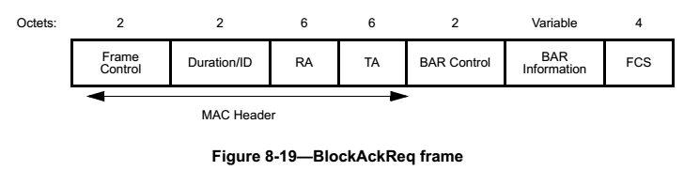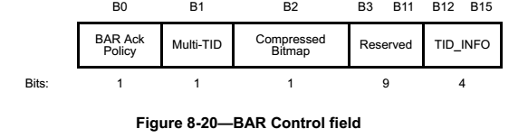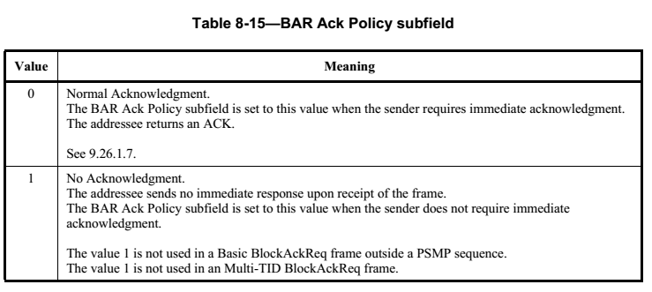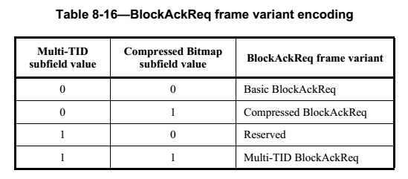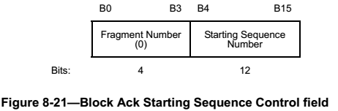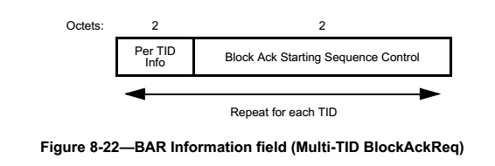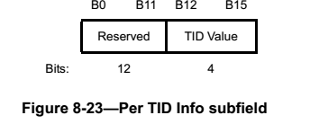

## BlokcAck Frame

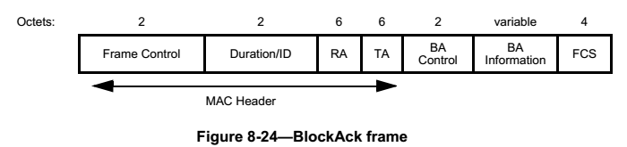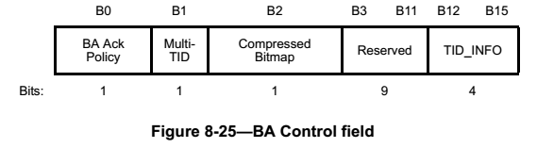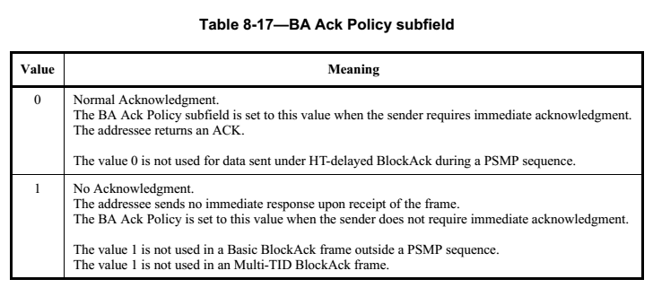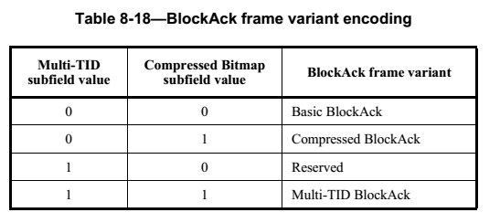

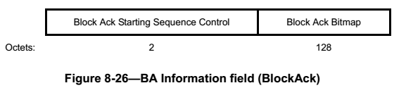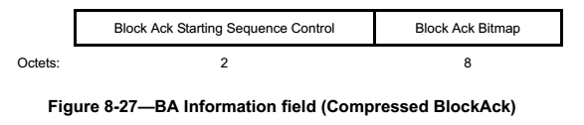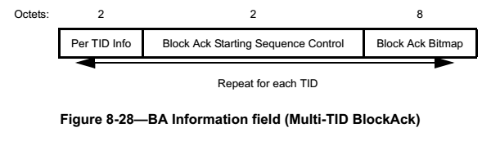

## Control Wrapper Frame

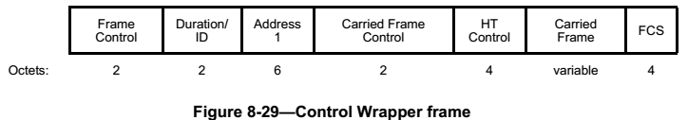

# Data Frames

## Data frame format

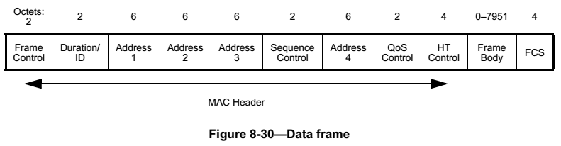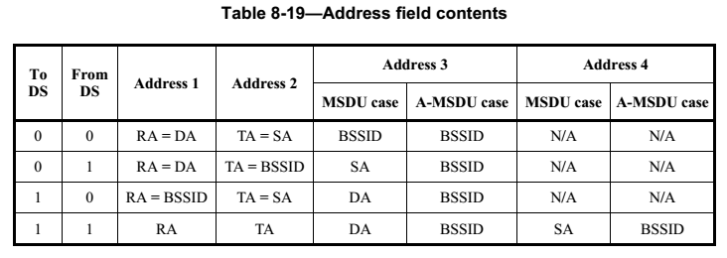

## A-MSDU format

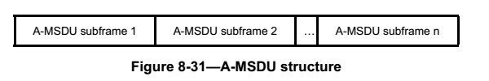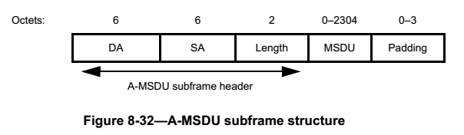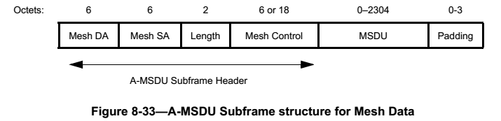

# Management Frames

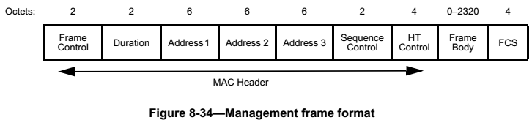

## Beacon frame format

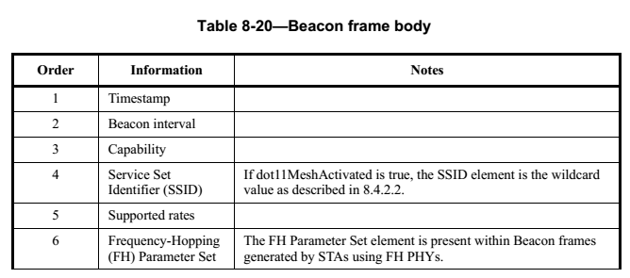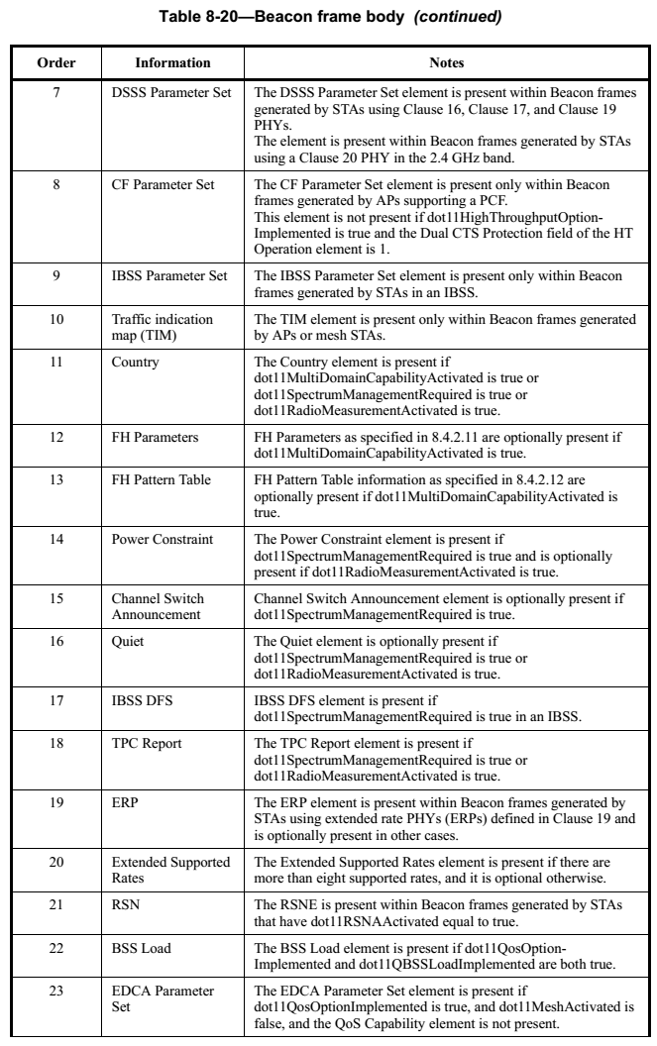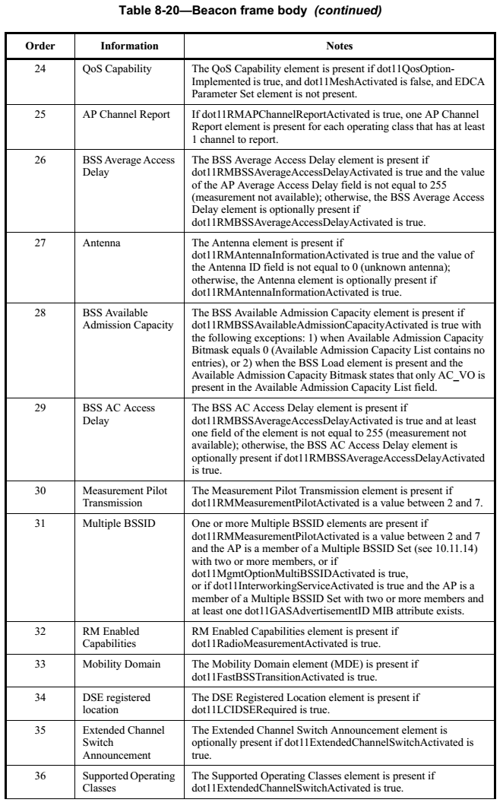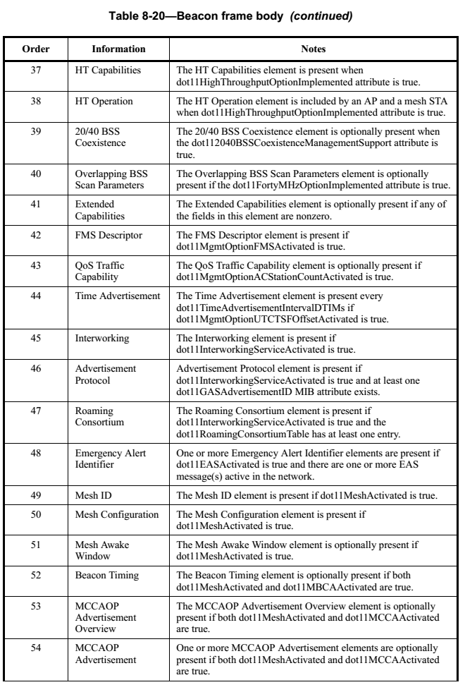

## ATIM frame format

The frame body of a management frame of subtype ATIM is null.

## Disassociation frame format

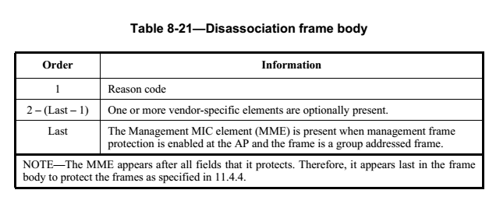

## Association frame format

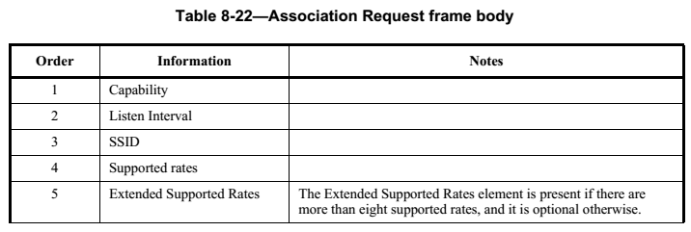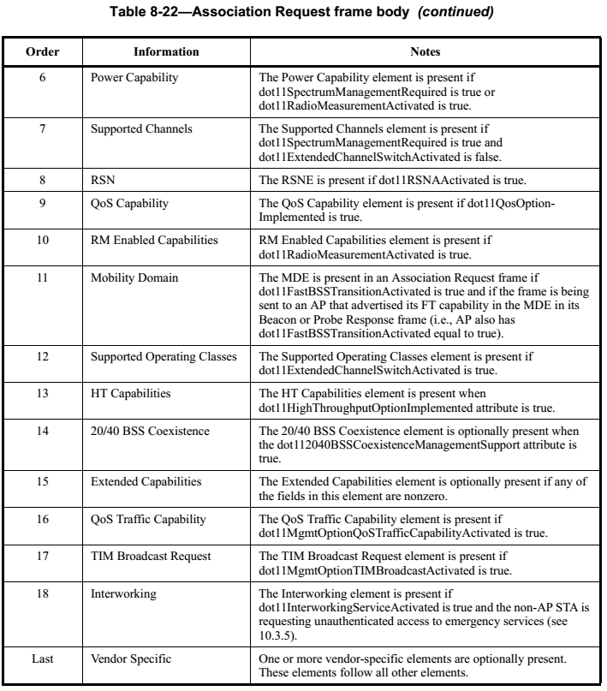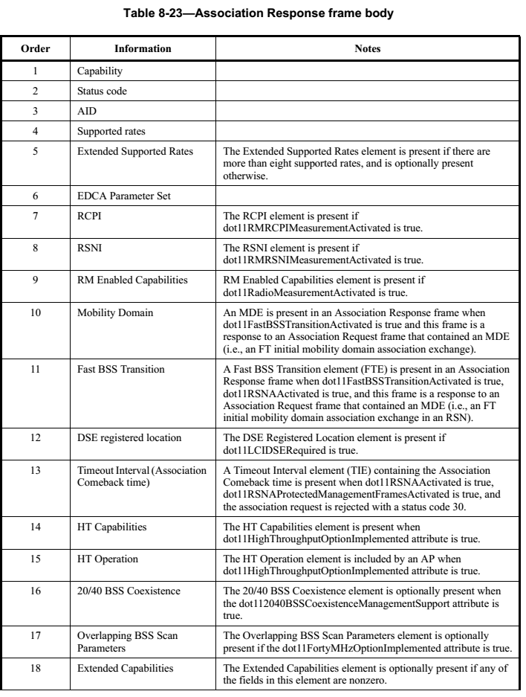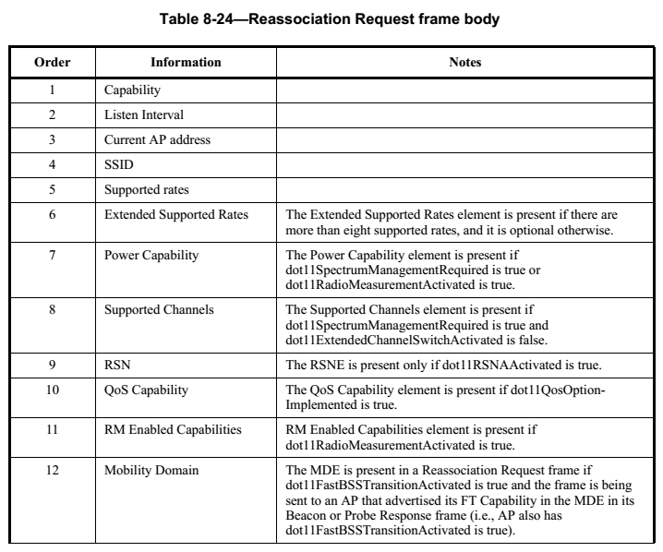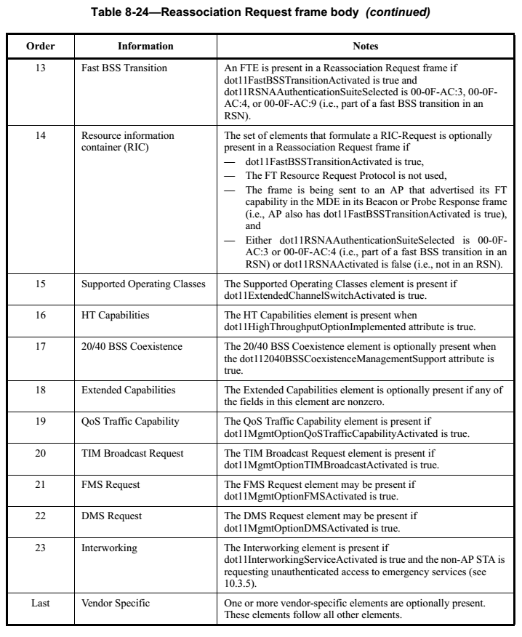

## Association Response frame format

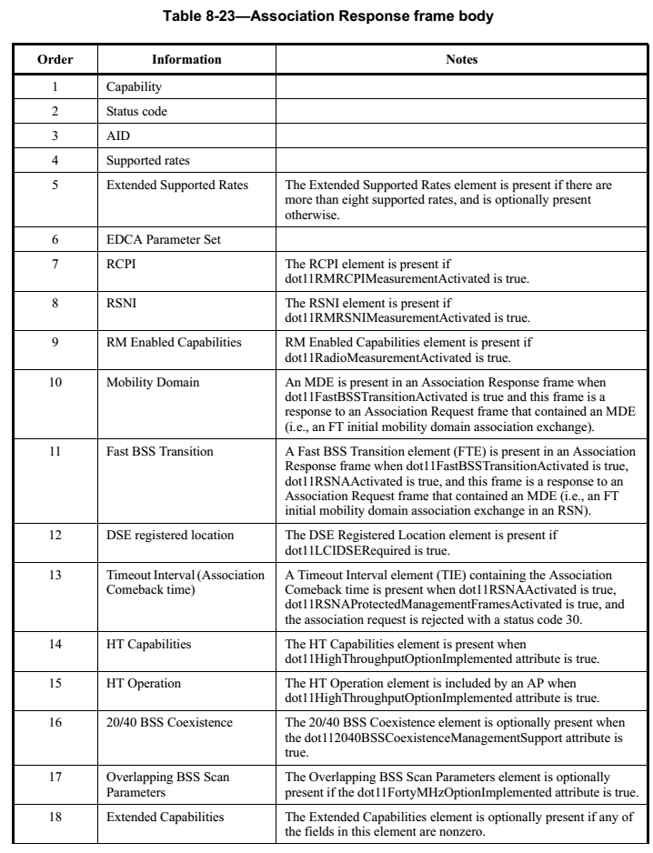

## Reassociation Request frame format

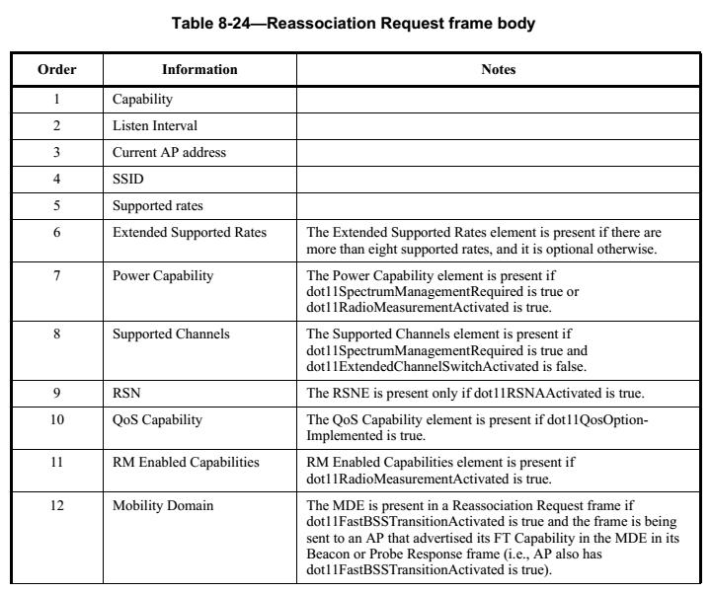 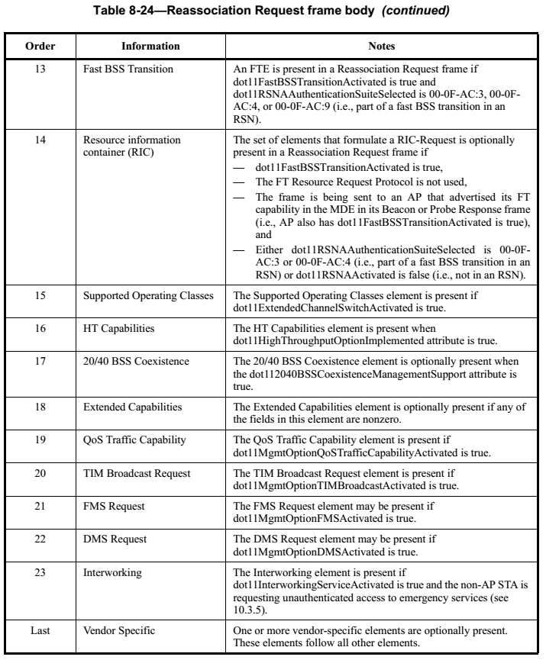

## Reassociation Response frame format

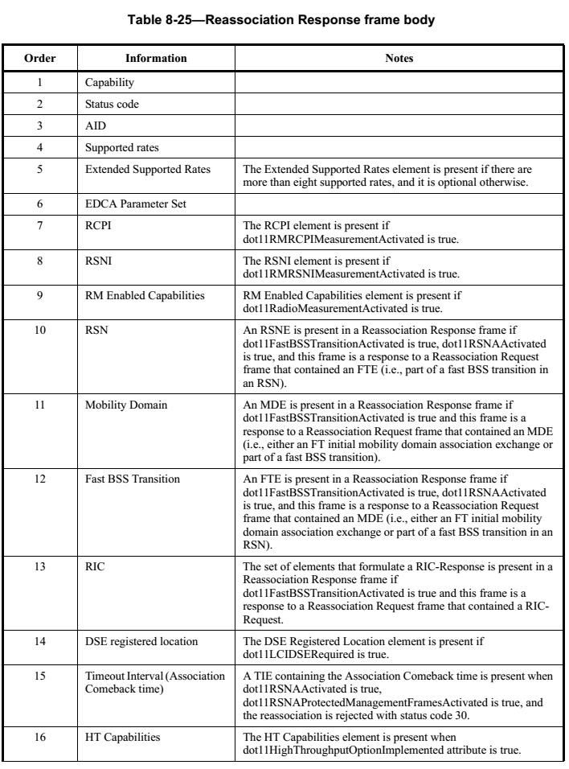 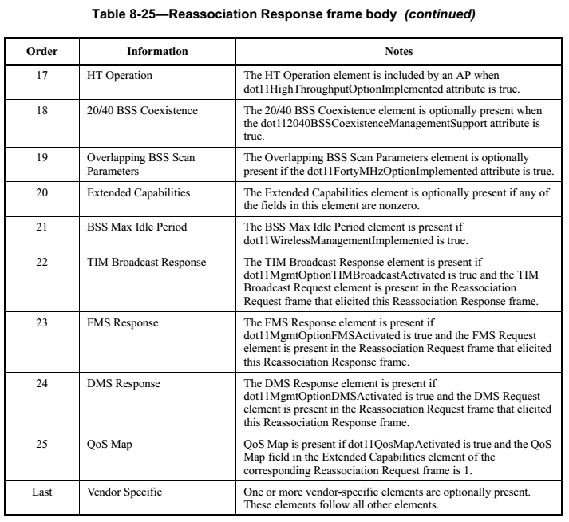

## Probe Request frame format

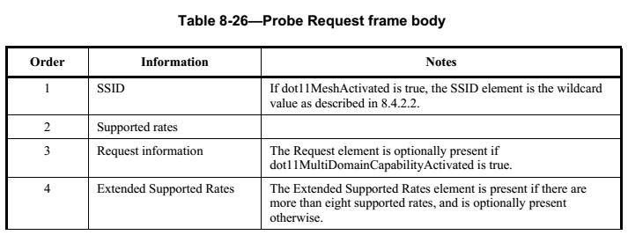 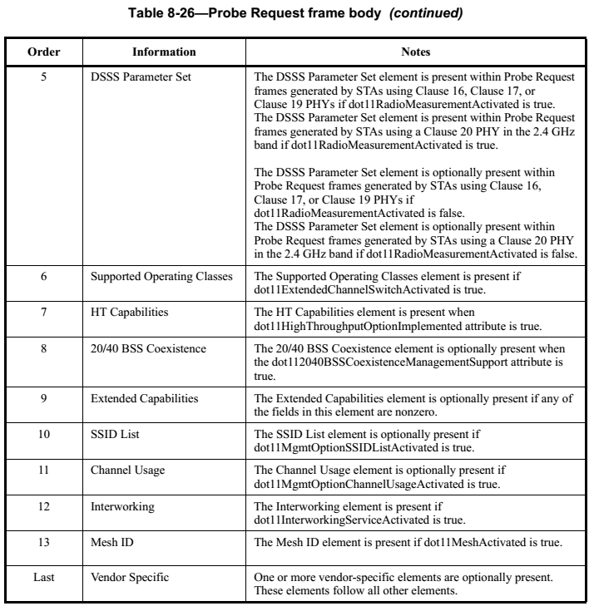

## Probe Response frame format

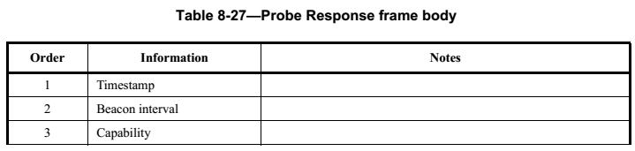 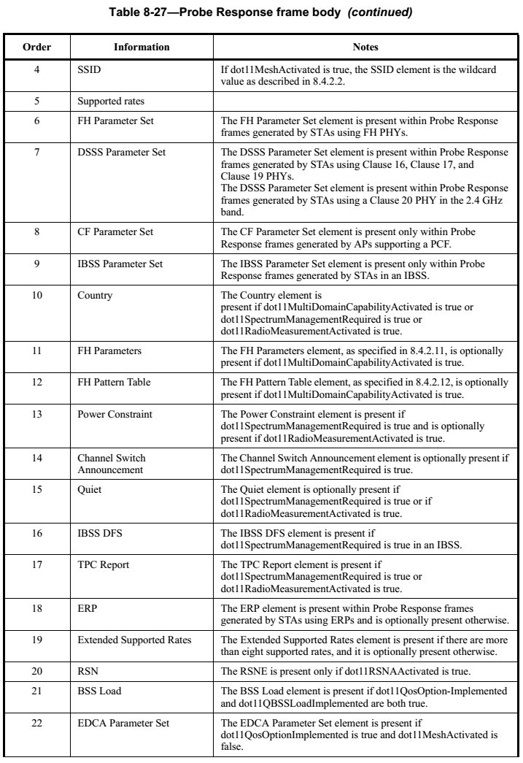 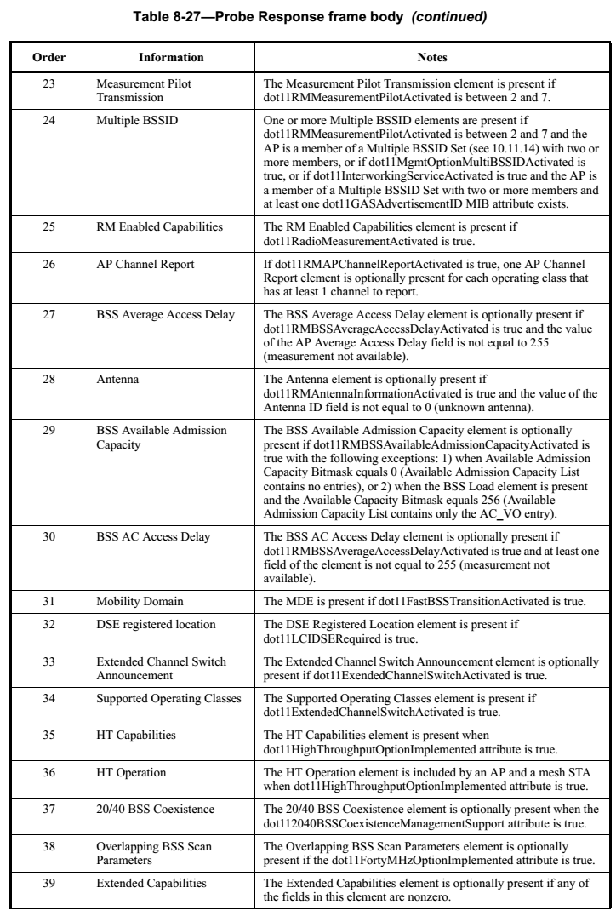 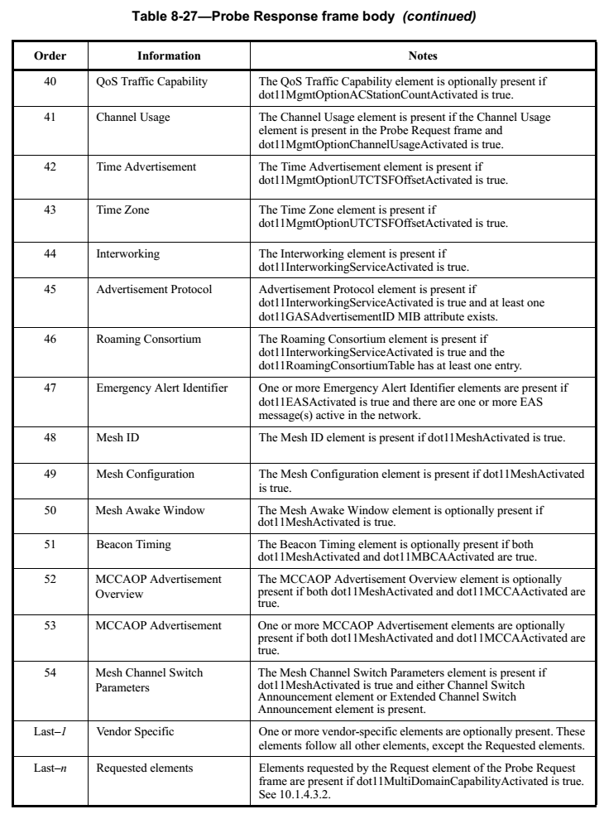

## Authentication frame format

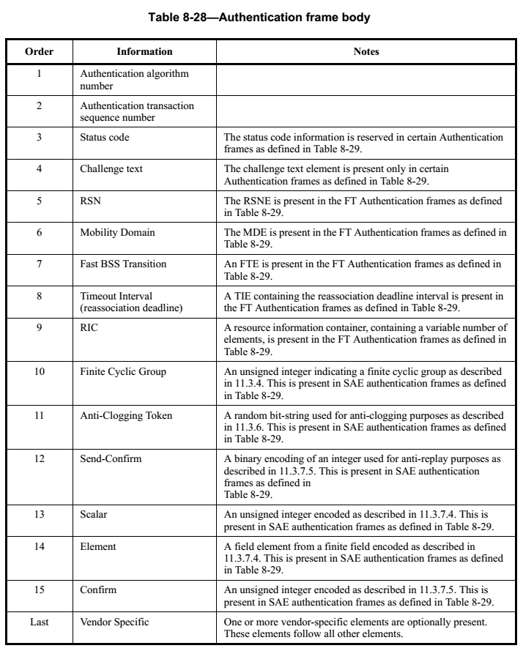 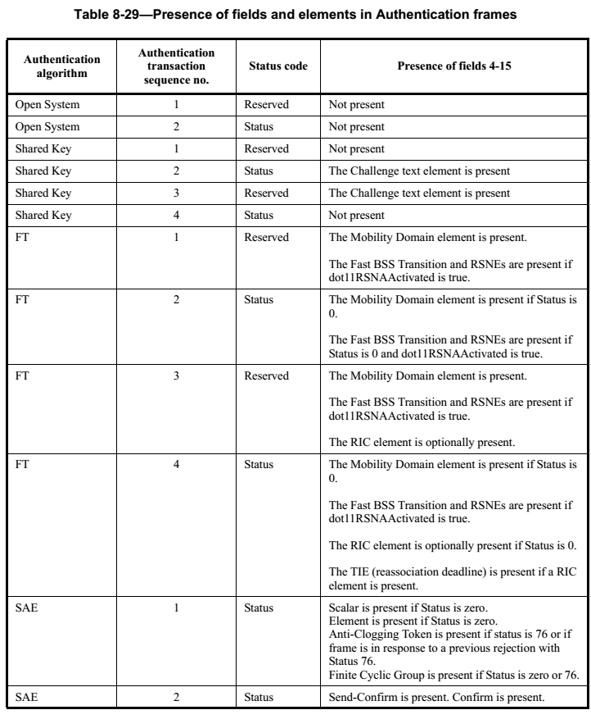

## Deauthentication frame fortmat

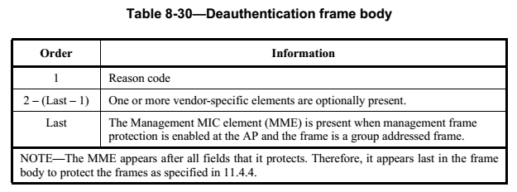

## Action frame format

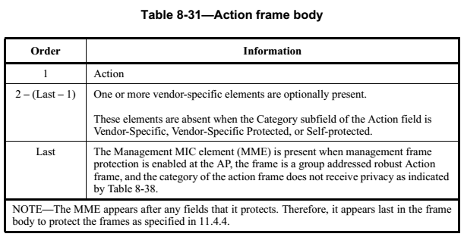

## Action No Ack frame format

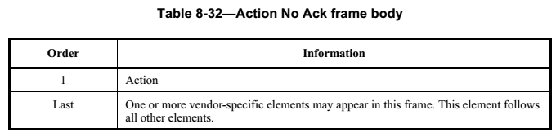

## Timing Advertisement frame format

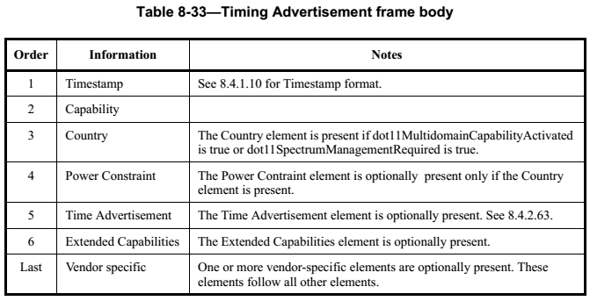

# Aggregate MPDU (A-MPDU)

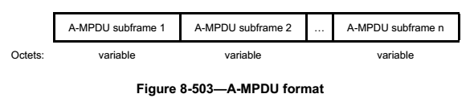 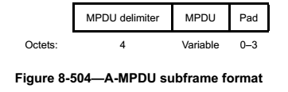 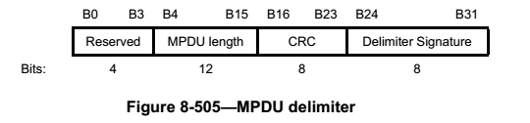 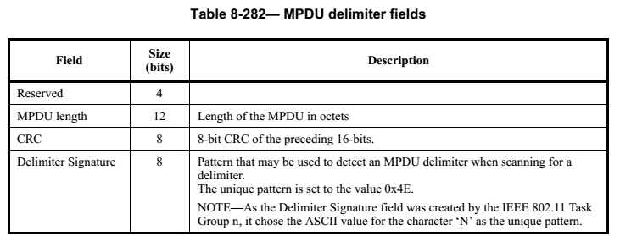 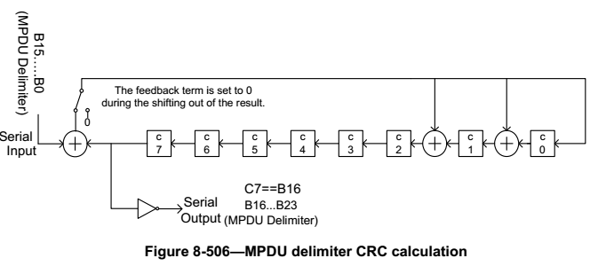 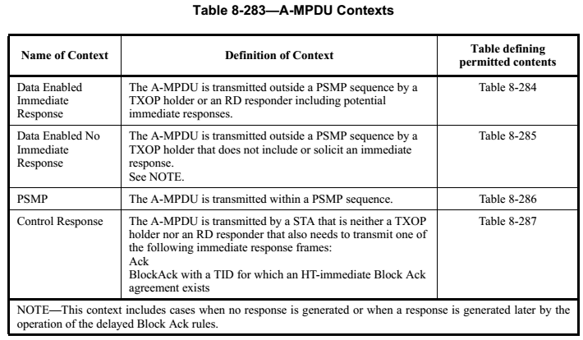 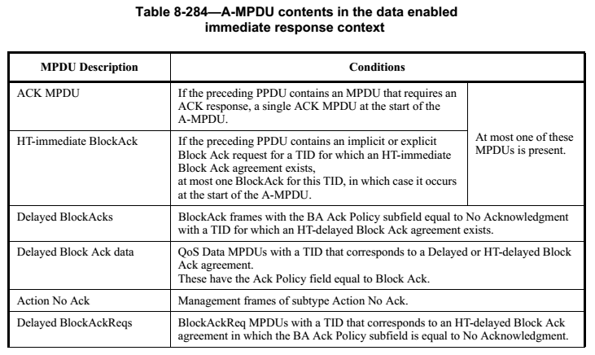 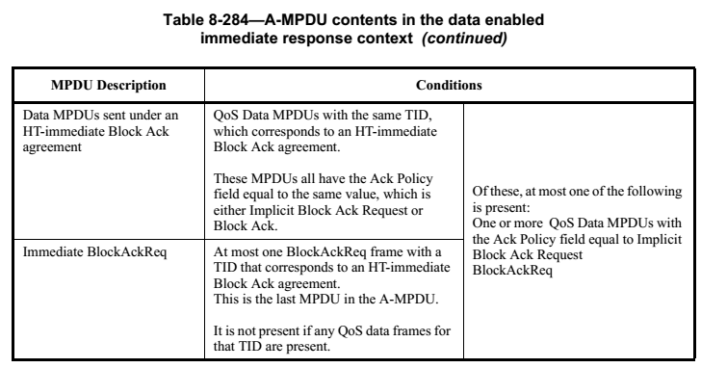 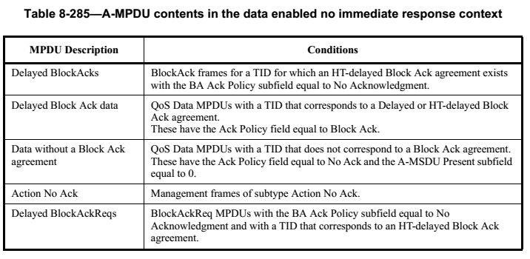 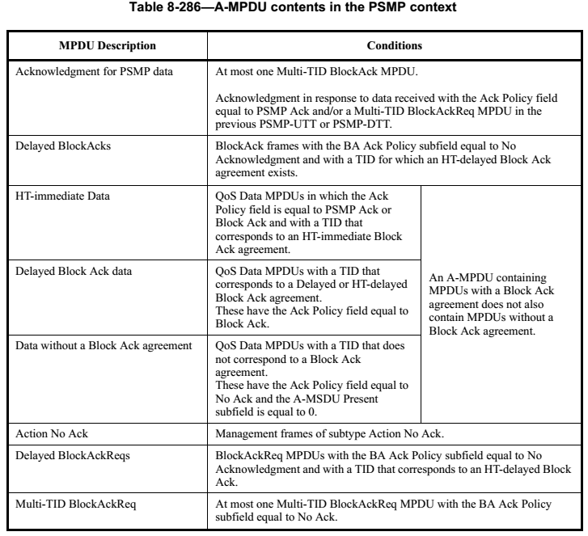 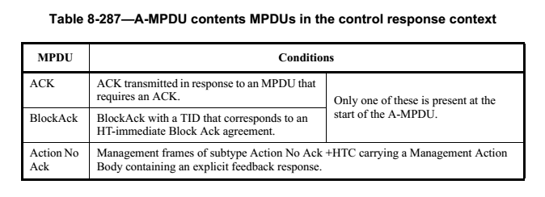

# RS9113-WiSeConnect Architecture

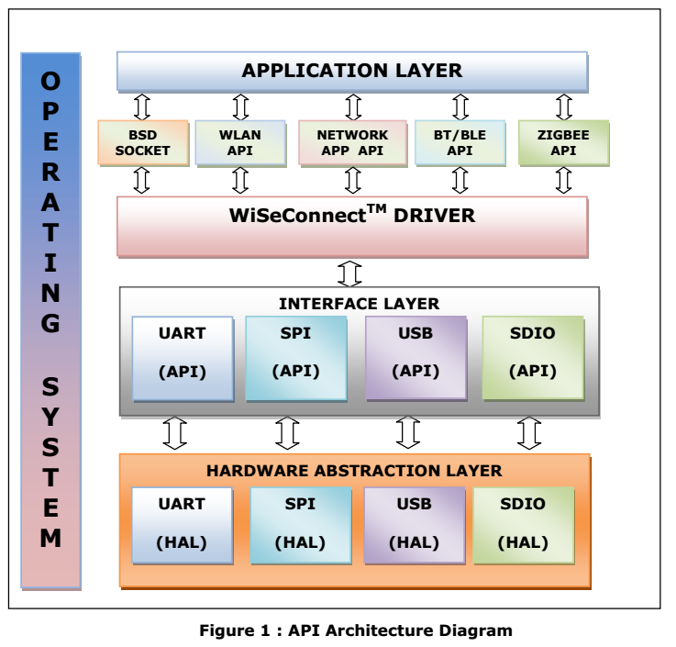

# OSI七层协议与TCP/IP四层协议

|  |  |  |  |  |  |  |
| --- | --- | --- | --- | --- | --- | --- |
| **OSI vs TCP/IP** | | | | | | |
| **OSI七层网络模型** | **数据格式** | **功能** | **TCP/IP四层概念模型** | **对应网络协议** | **对应的典型设备** | **区域** |
| **应用层（Application)** |  | **文件传输，电子邮件，文件服务，虚拟终端** | **应用层** | **TFTP、FTP、NFS、WAIS** | **应用程序，如FTP，SMTP，HTTP** | **计算机** |
| **表示层(Presentation)** |  | **数据格式化，代码转换，数据加密** | **Telnet、Rlogin、SNMP、Gopher** | **编码方式，图像编解码、URL字段传输编码** |
| **会话层(Session)** |  | **解除或建立与别的接点的联系** | **SMTP、DNS** | **建立会话，SESSION认证、断点续传** |
| **传输层(Transport)** | **数据组织成数据段Segment** | **提供端对端的接口** | **传输层** | **TCP、UDP** | **进程和端口、四层交换机、也有工作在四层的路由器** |
| **网络层（Network)** | **分割和重新组合数据包Packet** | **为数据包选择路由** | **网际层** | **IP、ICMP、ARP、RARP、AKP、UUCP** | **路由器，防火墙、三层交换机** | **网络** |
| **数据链路层（Data Link）** | **将比特信息封装成数据帧Frame** | **MAC检测以及错误检测功能,物理链接检测** | **网络接口** | **FDDI、Ethernet、Arpanet、PDN、SLIP、PPP** | **网卡（其实网卡是一半工作在物理层、一半工作在数据链路层），网桥，二层交换机** |
| **物理层（Physical）** | **传输比特（bit）流** | **以二进制数据形式在物理媒体上传输数据** | **IEEE 802.1A、IEEE802.2到IEEE802.11** | **中继器，集线器、网线、HUB** |

# END